**CREATE USER ACCOUNT**







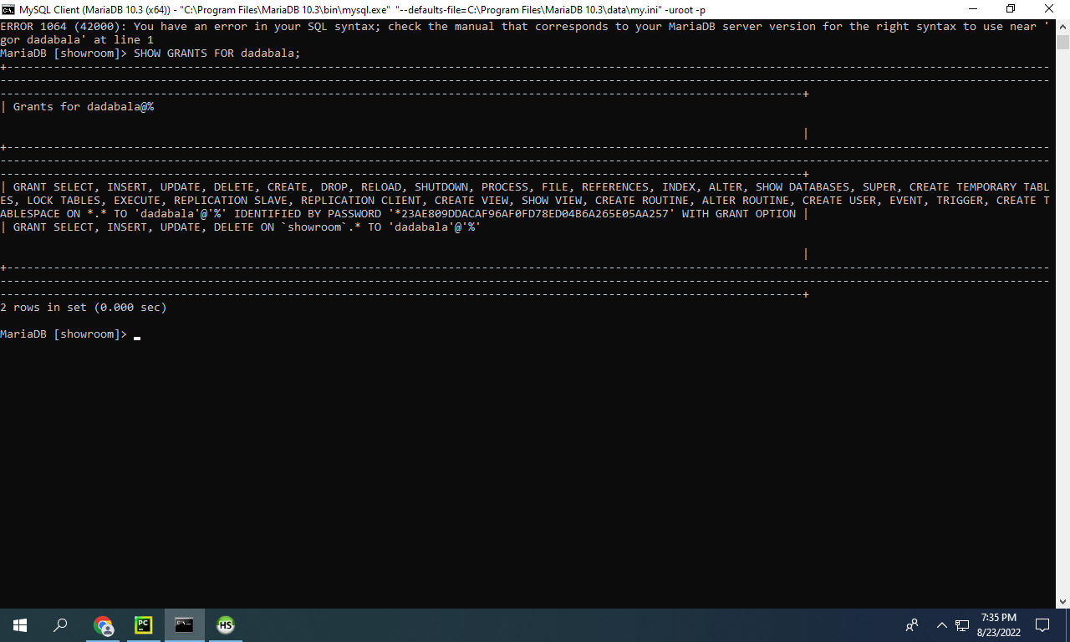

Connection to dadabase:

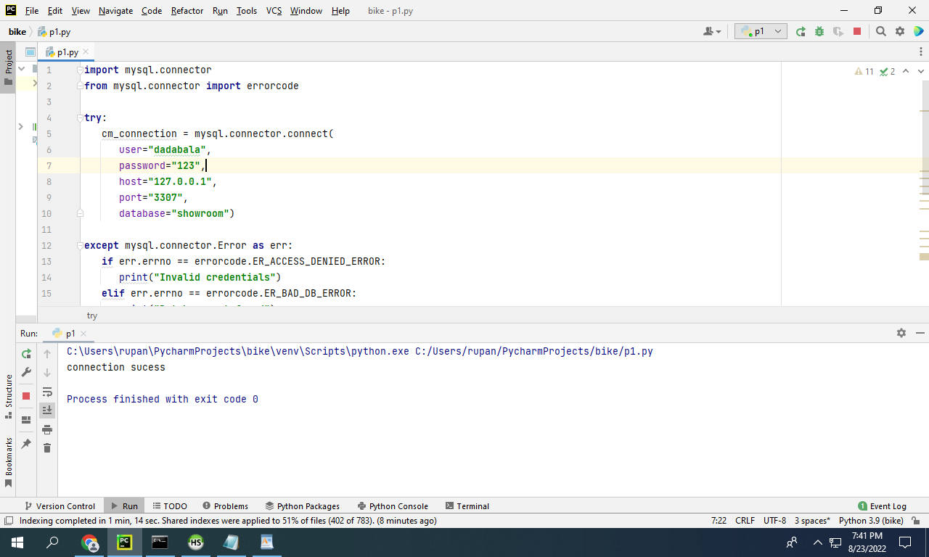

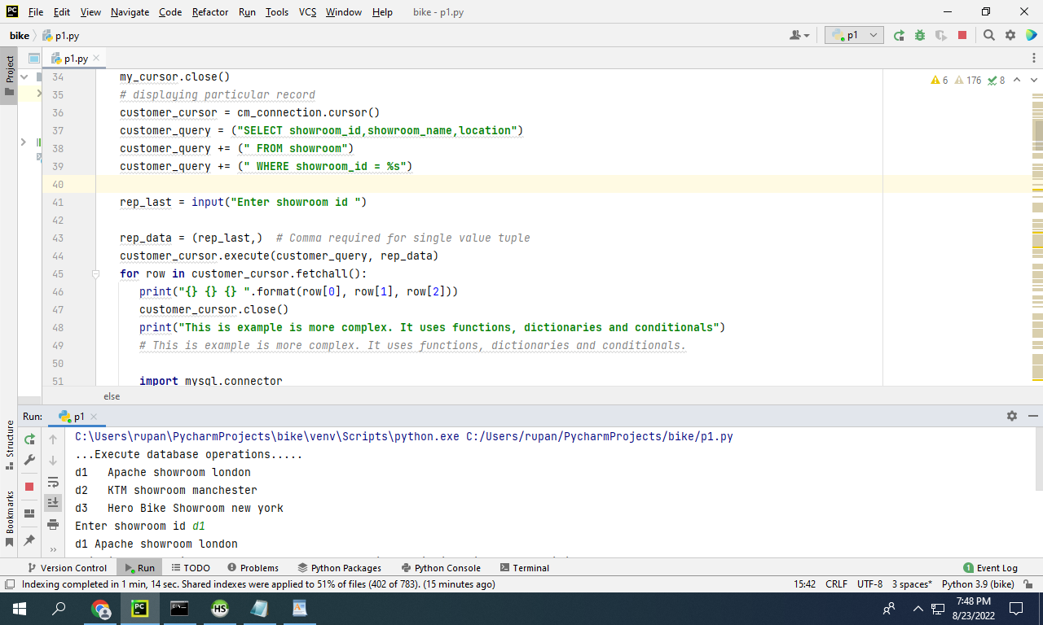

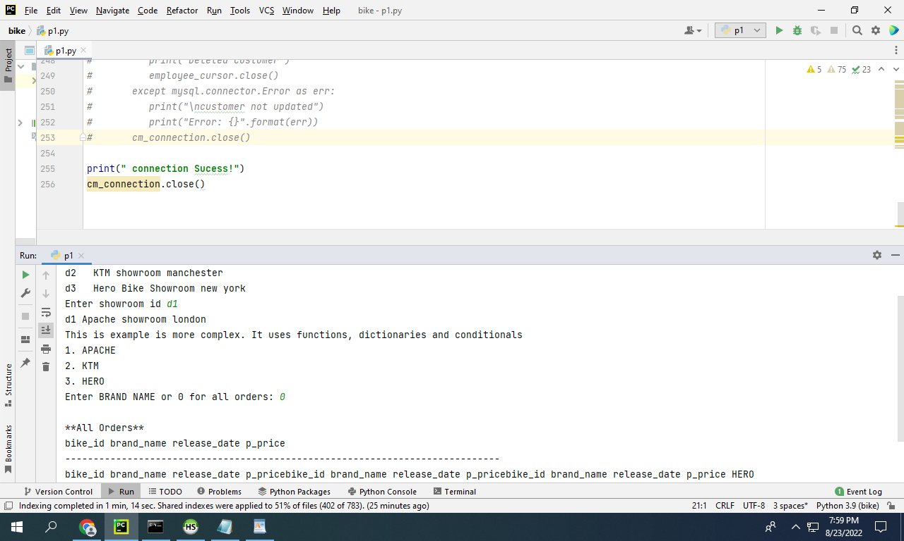

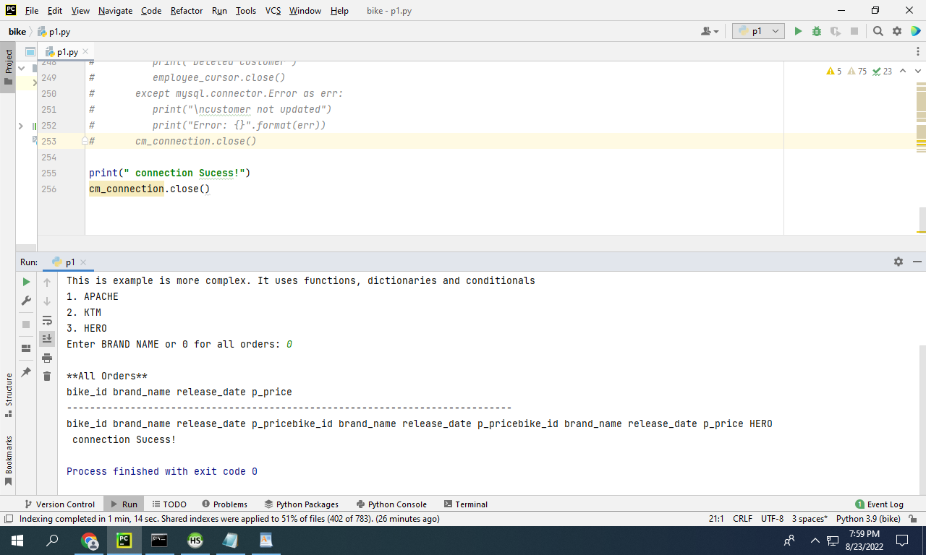

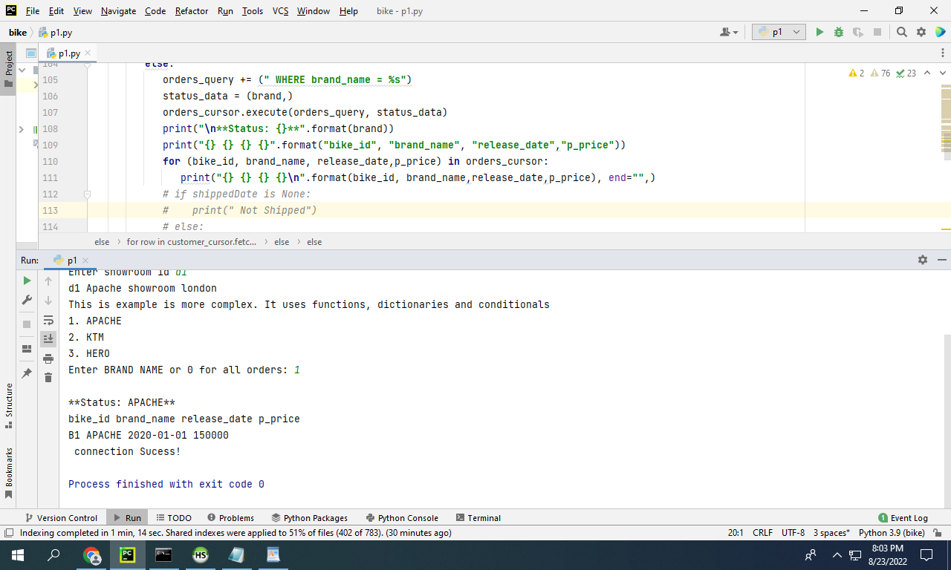

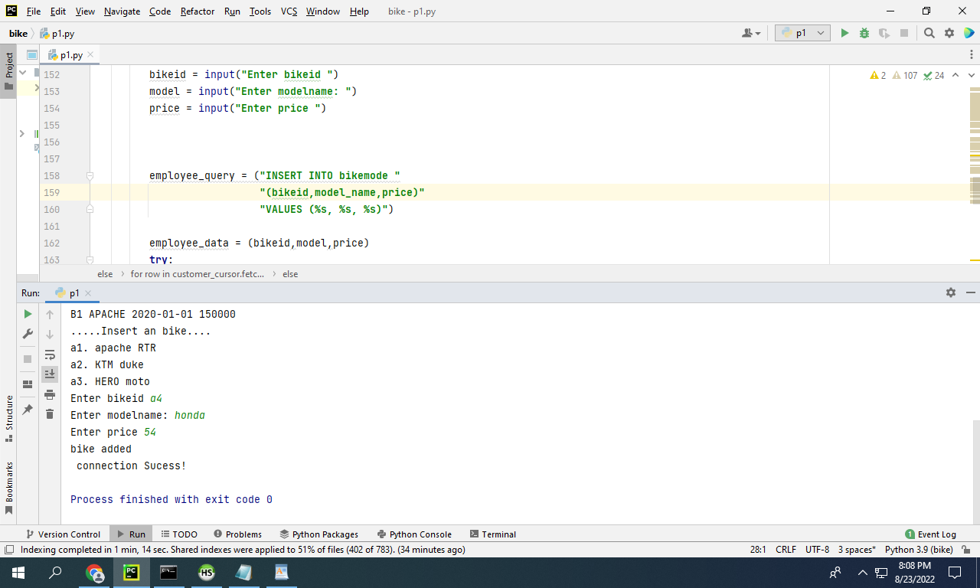

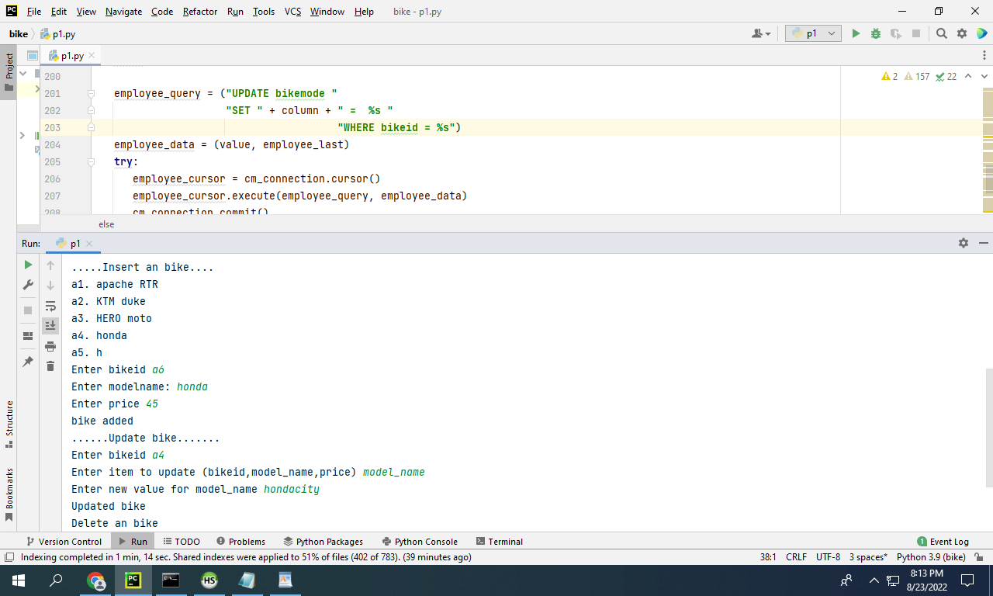

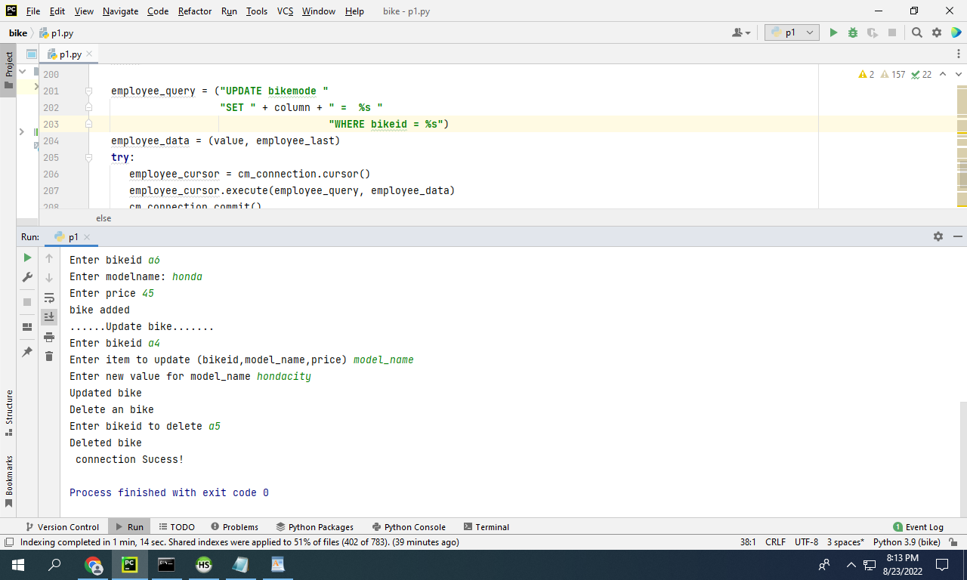

10 points for Internal comments – they must accurately describe each of the following:

The purpose of the program

The connection to the database

The creation of the cursor object

The SQL query string and execution

Answer:

The cause of this system is grocery enterprise for digitalization. In this project we are trying to show some of the special systems related to developing the database for the digitization of the byke showroom improved appreciably over the last ten years, and the net has had a great effect on converting client behavior. The ability to get the whole lot wished with a single click on or faucet and feature it brought proper on your door has now no longer best begun out a trend, however it has additionally given on line companies extra opportunities. It has proven a great boom and finished high-quality income and received extra users.

For growing the database the python code is administered with SQL in HeidiSQL platform. HeidiSQL is a reliable and really useful device for the usage of MariaDB. It can allow us to edit and skim the information, edit and create tables or time tables on any occasions etc. The cursor is a form of transient reminiscence that is used for storing the database tables. The item tables that are created for this system are brands, category, client details, grocery objects and store.

Now, the queries that are carried out in SQL are insert, replace, delete etc. as proven in the photo above. The insert question facilitates new rows to the desk. The replace question facilitates altering the information in the desk. And the delete question is used for deleting the prevailing information in the database desk. It is a one to many dating. The one to many dating may also manifest if any document from a desk is associated with one or many information in some other desk. Also in some other desk one document won't be associated with a couple of documents in the preceding desk. In the above screenshot the final results are proven.